Assignment – 01
- Write a program to perform below operations on Boolean type to convert:
a. Boolean value into String
b. Boolean value into a Boolean instance.
c. String value into Boolean value
d. String value into a Boolean instance.

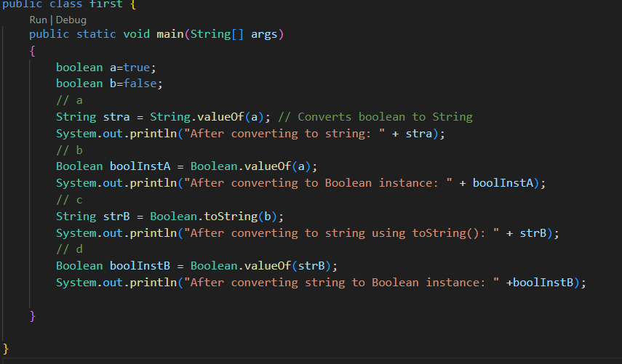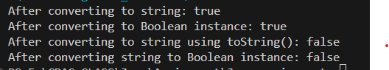

- Write a program to perform below operations on byte type to get:
a. The number of bits used to represent a byte value
b. The number of bytes used to represent a byte value
c. The minimum value a byte

